AI Assisted Coding
Assignment 19.3
Name: V.Tharun varma
Rollno: 2303A52265
Batch: 45
Task 1 – Python to C++ Conversion
Translate a simple Python class into C++ using AI assistance.
Instructions:
- Prompt AI to convert a Python class representing a Student with attributes and methods into equivalent C++ code
- Ensure proper handling of:
o Constructors o Data types o Access specifiers
- Compile and run both versions to verify output consistency Expected Output:
An equivalent working C++ class translated from Python
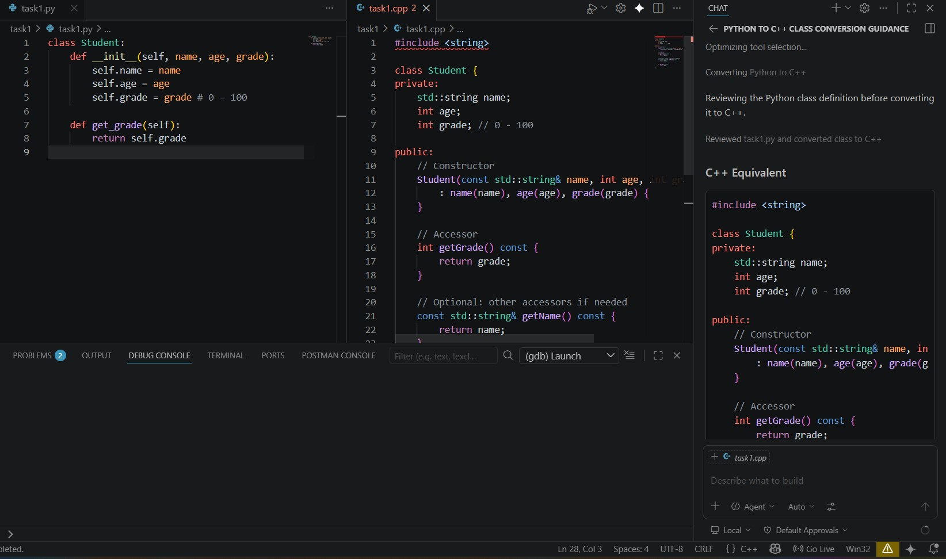

Task 2 – Java to Python Function Conversion
Convert a Java method that checks whether a number is prime into Python.
Instructions:
- Ask AI to translate a Java isPrime() method into Python
- Test the function with multiple inputs
- Ensure the Python version follows Pythonic syntax and logic Expected Output:
A correct Python function equivalent to the original Java prime- checking method.
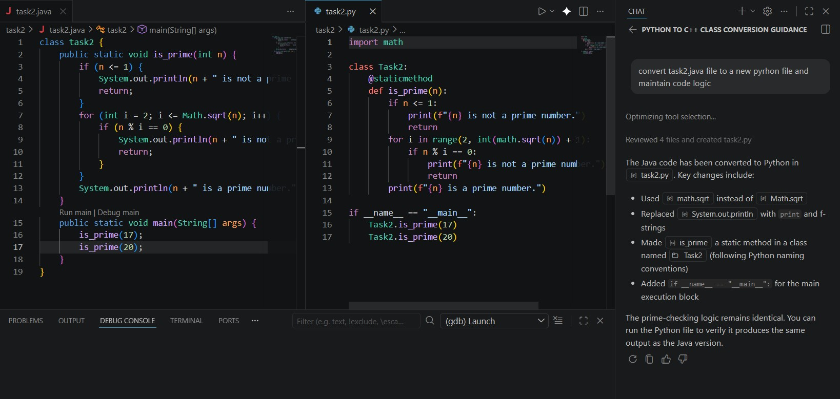

Task 3 – Pseudocode to Python Implementation
Translate a given pseudocode algorithm into Python using AI.
Instructions:
- Provide AI with pseudocode for sorting numbers (e.g., bubble sort or selection sort)
- Ask AI to convert it into executable Python code
- Validate correctness using sample input lists Expected Output:
A working Python program that correctly implements the pseudocode logic
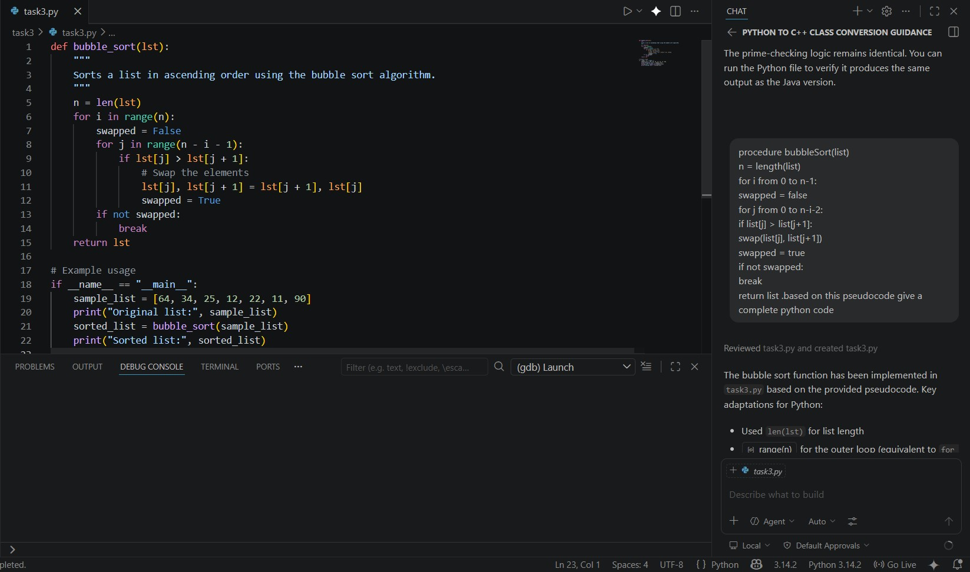
Task 4 – SQL to Pandas Query Task:
Translate a SQL query into a Pandas DataFrame operation in Python.
Instructions:
- Provide AI with a SQL query (e.g., SELECT name, salary FROM employees WHERE salary > 50000).
- Ask AI to generate equivalent Pandas code.
- Test the generated code on a sample DataFrame.
Expected Output:
- Equivalent Pandas query that retrieves the correct subset of data.
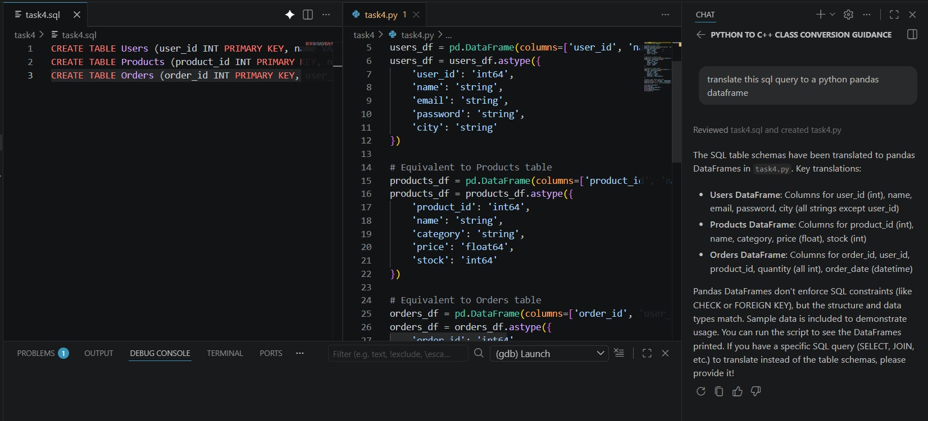
Task 5 – Real-Time Application: Algorithm Translation Across Languages Scenario:
A company maintains algorithms written in different programming languages.
Examples:
- Converting a Python searching algorithm into C • Translating a Java sorting program into JavaScript Instructions:
- Use AI to translate a selected algorithm between two programming languages
- Execute and test both versions
- Document translation challenges such as: o Syntax differences o Library support o Memory management Expected Output:
Equivalent, tested code implementations in two different programming languages.
